
./
Power Window Report


Ver. Rel. No. | Release Date | Prepared. By | Reviewed By | To be approved By | Remarks/Revision Details
1 |  | 99003730(Arnav Kandpal)
Document History

Table of Contents
Table of Figures 3
Table of Tables 4
1:Introduction 4
ACTIVITY 2: RESEARCH…………………………………………………………………………………………………………………………………………………6
POWER WINDOW SWITCH INTERFACE……………………………………………………………………………………………………………………..6
IC USED IN POWER WINDOW CIRCUIT SWITCHES……………………………………………………………………………………………………..9
INPUTS………………………………………………………………………………………………………………………………………………….12
OUTPUTS………………………………………………………………………………………………………………………………………………16
ACTIVITY – 3 FEATURE- ‘ANTI-PINCH WINDOW’………………………………………………………………………………………..18
SWOT ANALYSIS………………………………………………………………………………………………………………………………….18
REQUIREMENTS………………………………………………………………………………………………………………………………….19
HIGH LEVEL REQUIREMENTS...……………………………………………………………………………………………………19
LOW LEVEL REQUIREMENTS...…………………………………………………………………………………………………….19
DESIGN………………………………………………………………………………………………………………………………………………20
IMPLEMENTATION……………………………………………………………………………………………………………………………20
TEST PLANS 11

Table of Figures
Figure 1 DEPLOYMENT DIAGRAM(HIGH LEVEL) 8
Figure 2 ACTIVITY DIAGRAM (LOW LEVEL) 9
Figure 3 CLASS DIAGRAM (LOW LEVEL) 10

Table of Tables

Table 4 HIGH LEVEL TEST PLAN 10
Table 5 LOW LEVEL TEST PLAN 10
Table 6 USER STORIES 15

- INTRODUCTION

  - Power Windows
Power windows have a structure much like the hand powered or manual windows. The difference is the handle bars are replaced with motor and the motion is now actuated with the actuator or power circuit thus the name “Power Window”.
Here is the motor and window setup on the door panel for Power window:

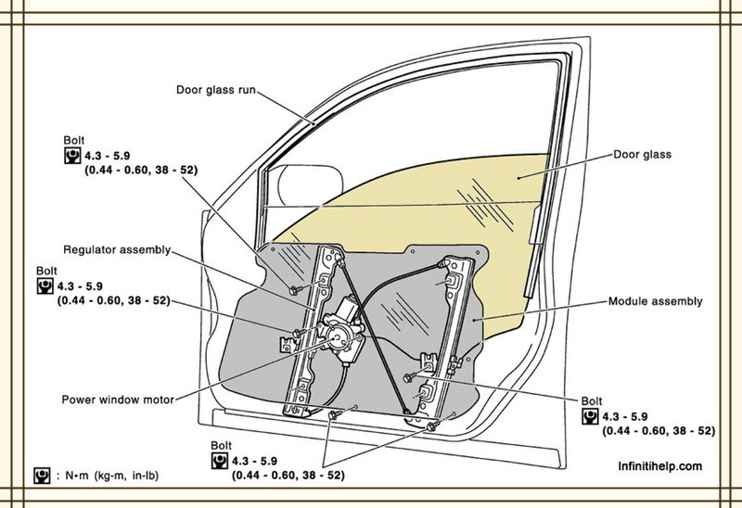

  - Objective
- To design a power window module with anti-pinch mechanism.

  - Architecture Philosophy

- Power Window Motor Configuration inside the car is generally as follows:

- 5- Switches on driver side (4 Window Switch and 1 Disable Passenger Switch)
- 1 switch each on rest of the remaining doors
- Total of 7 Switches.

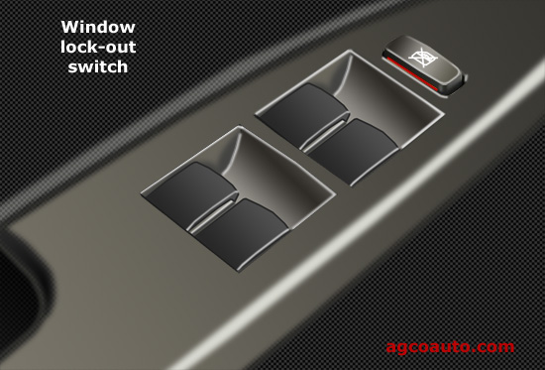

- By pushing the switch downwards, the window pane will start moving downwards, and while pulling upwards the window pane, will start moving upwards, at any point the switch is released the window pane will remain stationary at that position.
- The window pane movement is distributed across 2 LRU’s: Input Interface Unit, motor control unit.

- Power Window System Requirements

  - High Level requirements

- Power Window feature should be implemented.
- Driver should get more priority than the passenger.
- Anti-Pinch feature should be implemented.

  - Low Level Requirements

- The window should go up upon pulling up the Rocker switch to a maximum position of 5.
- The window should go down when pushing down the rocker switch to a minimum position of 0.
- The window should come to halt at any stage of operation by releasing the toggle switch.
- When the driver pulls up the switch and passenger push down the switch at same time the window should go up.
- When the driver pushes down the switch and passenger pull up the switch at same time the window should go down.
- When the switch is pushed down to a position of -2 the window should enter the operation express down.
- The Express up should be cancelled by the user pushing down the switch.
- The Express down should be cancelled by user by pulling up the switch.
- When the switch is pulled up to a position of 2 the window should enter the operation express up.
- Presence of a disable passenger window switch as for child safety.
- An obstruction should be detected when motor draw crosses the threshold set as 3.
- On Detection of an obstruction the Anti-Pinch System should move the window pane to a position of 0.
- When Anti-Pinch function is in action any command given by the driver should be neglected until the window pane reaches the reset position of 0.
- When Anti-Pinch function is in action any command given by the passenger should be neglected until the window pane reaches the reset position of 0.

ACTIVITY – 2 RESEARCH

- Power Window Switch Interface:

Power windows often employs “Rocker Switch” or “Toggle Switch”
- “Rocker” switches are designed to pivot on a center hinge, effectively operating like a “see-saw.”
- “Toggle” switches operate using small levers that push back and forth to open and close a window.
- Here is the internal circuitry for GMC Sierra for an instance of communication between driver switch, passenger switch, and the window pane to control.
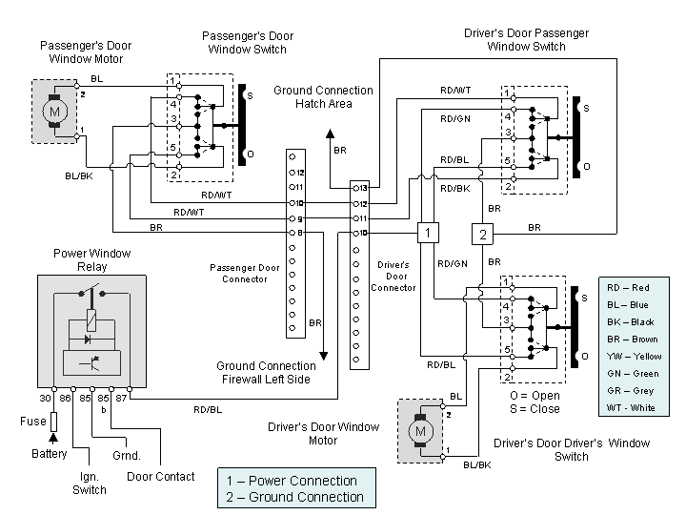

Driver Power Window Switch: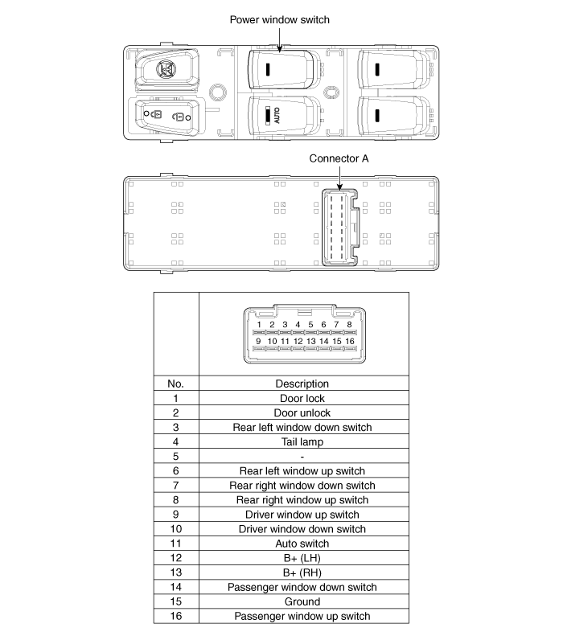

Passenger Power Window Switch
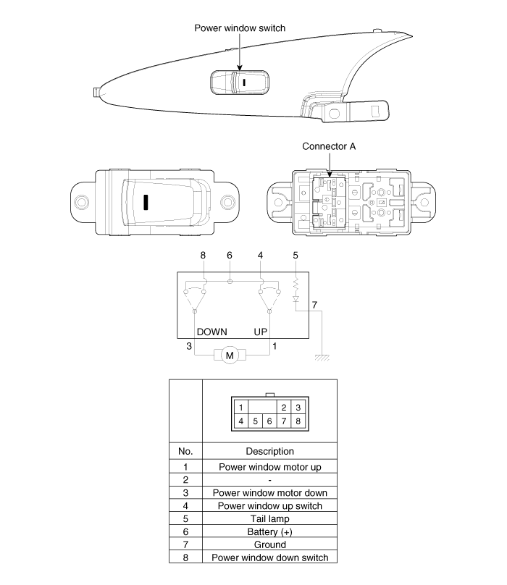
- IC used in power window circuit switches:
Many different types of internal circuit can be used in the power window operation but we will be focusing on the KA3903 as it supports 2 different mode for same motor which would be useful for the anti-pinch operation.

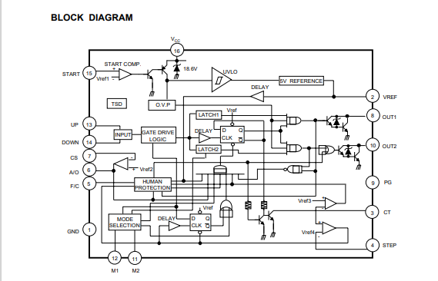
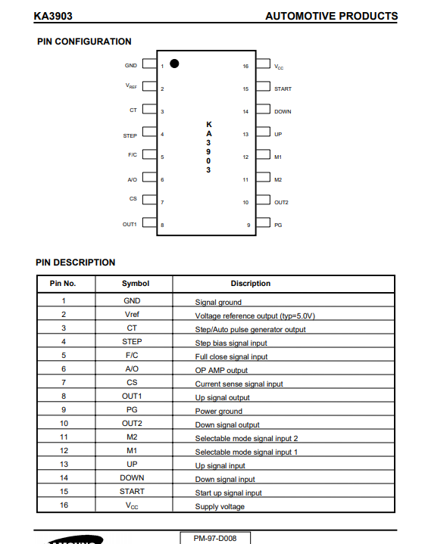
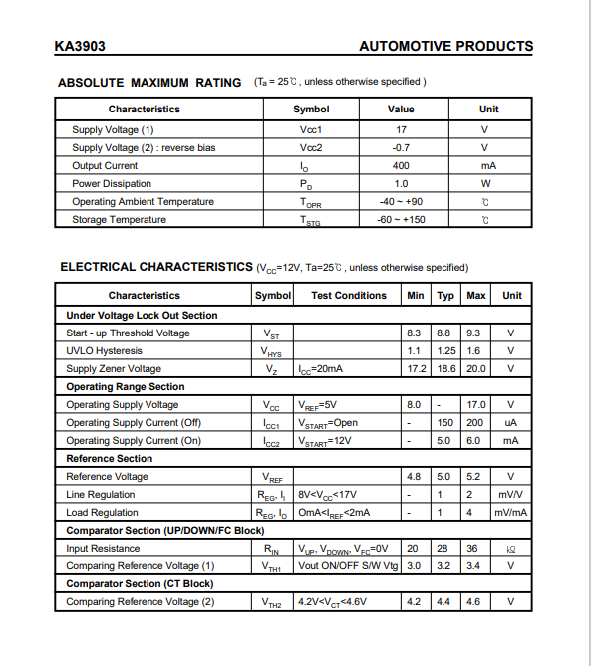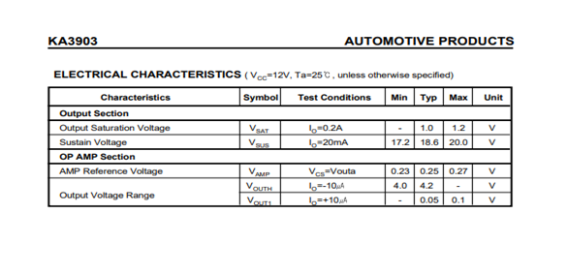

- Inputs
- Rocker Switches:
“Rocker” switches are designed to pivot on a center hinge, effectively operating like a “see-saw.”
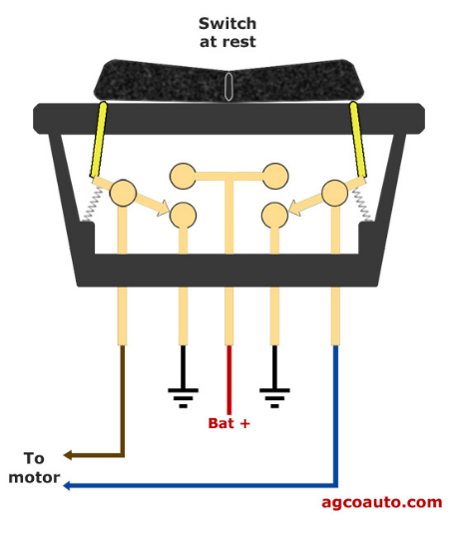

- Position Sensor:
- Reed sensors are generally used as the position sensor for power windows.
- Every time the magnet passes through the sensors it detects speed and direction.

Sensor 1: We will be using Infeneon TLE5009 series Reed Sensors:
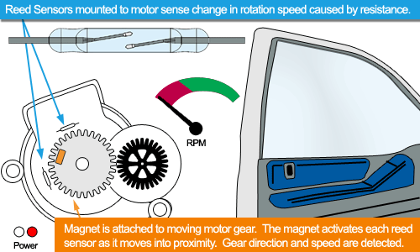
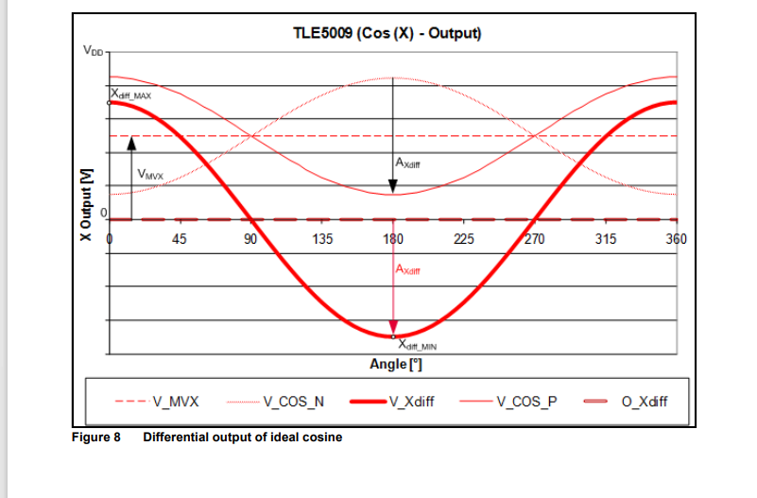
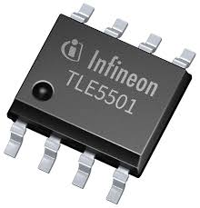

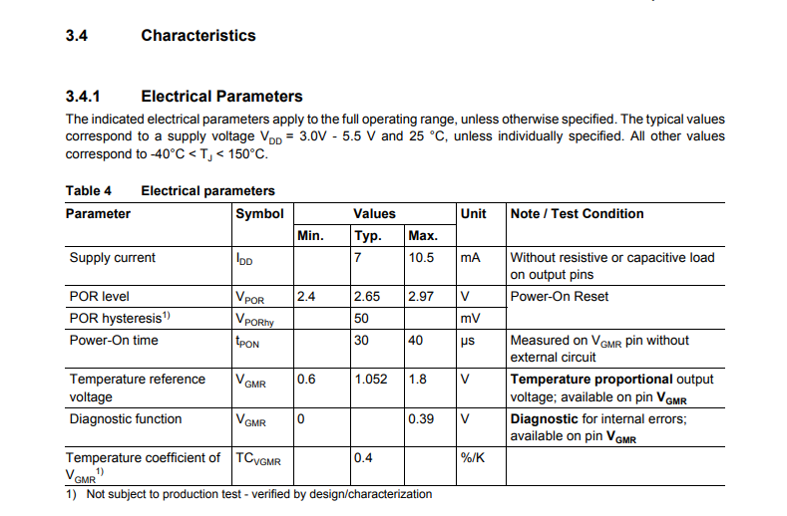

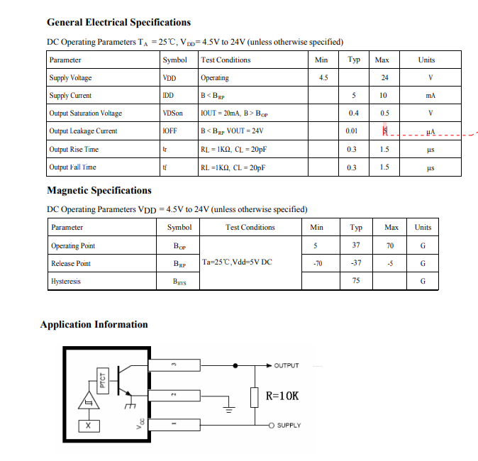
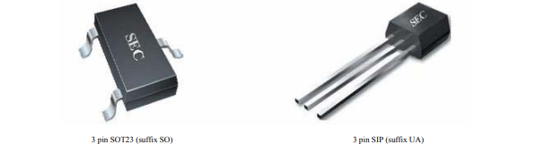
Sensor 2: A Similar sensor is SEC SS41
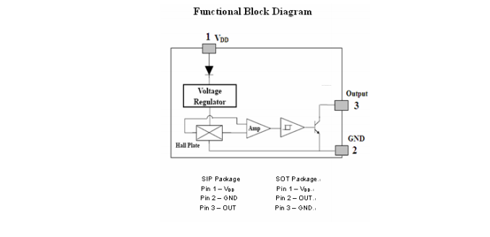
Sensor 3: Another good sensor is Standex Electronics MK15

- Current Sensor:
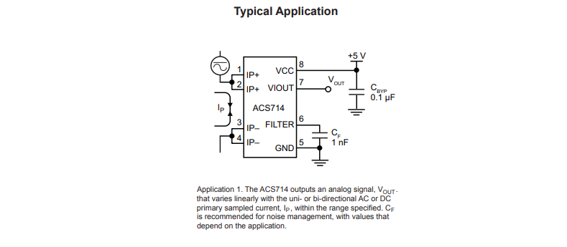
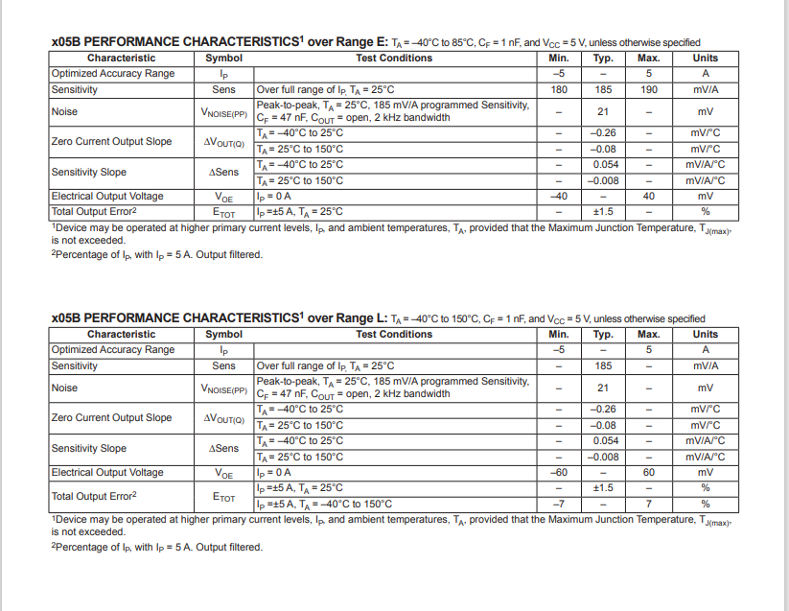
We are using ACS714ELCTR-05B-T, Automotive Grade, Fully Integrated, Hall Effect-Based Linear Current Sensor IC with 2.1 kVRMS Voltage Isolation and a Low-Resistance Current Conductor as our current sensor.
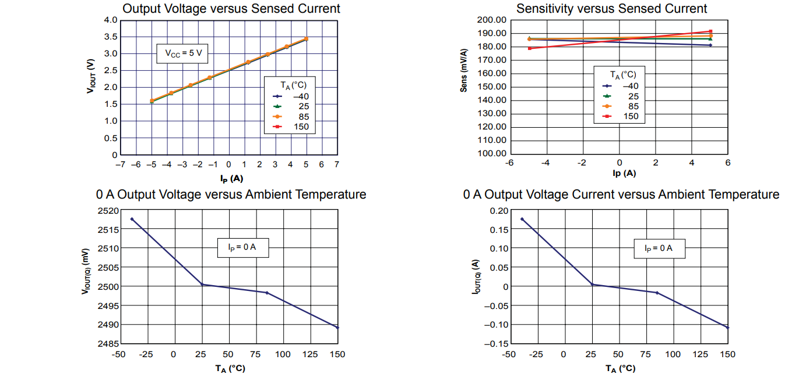
While other good option for current sensors are

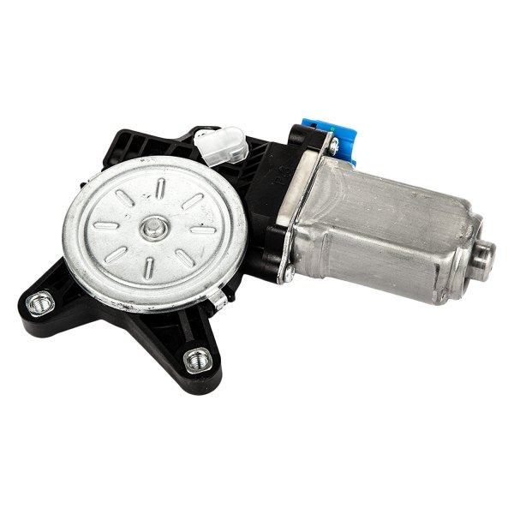
- Outputs:
- Motor Specifications:
The motor we have considered is ACDelco 95391354- GM motors original part

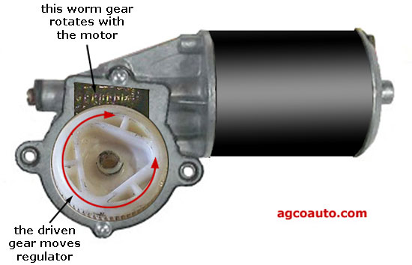

Here are the specs for a typical motor of a power window with a standard 12V input and variable current draw depending upon the load on the mirror.

The driven gear attaches to the regulator-drive gear, often using drive rollers. These rollers allow for any slight misalignment, smooth window travel and quite power window operation.
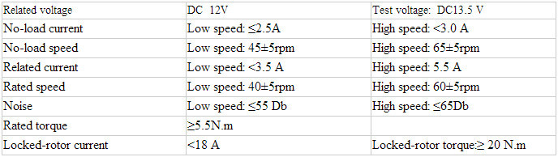

ACTIVITY – 3 FEATURE- ‘ANTI-PINCH WINDOW’

An anti-pinch system is a safety mechanism on a power window of cars that prevents drivers and the passengers from fatal injury and death caused by human body getting stuck or pinched in the window frame.
There are two types of mechanisms in which the anti-pinch system works: a non-contact method and a contact method. The non-contact system detects the position of the obstacle using sensors (for example, electromagnetic field sensor) to measure proximity distance of the obstacle that enters the sensor space-charge field before the window touches the obstacle. This approach is rarely used on power windows that incorporate anti-pinch system because it is a high cost of mechanism compared to the similar performance
This feature is employed using contact method by sensing the current draw on the motor.

SWOT ANALYSIS:

Strengths  - Cheaper than non-contact method  - Fewer parts thus easy maintenance  - Robust compared to non-contact method | Weakness  - Slower than non-contact methods
Opportunities  - Minimal cost to implement the feature.  - Older window panel can also be easily modified with this feature | Threats  - In extreme snow the ice also adds resistance to the window which can be interpreted as pinch and thus device failure

REQUIREMENTS:

- High-Level Requirements:

- The window should go up upon pulling up the Rocker switch
- The window should go down when pushing down the rocker switch
- The window should come to halt at any stage of operation by releasing the toggle switch
- The window should go down if it detects any obstruction on its way up

- Low-Level Requirements:

- The Window should give driver commands more priority than the passengers.
- Presence of a disable passenger window switch as for child safety.
- The system should be functional under heavy rain conditions.
- When any part of a stainless-steel sphere having a surface finish between 8 and 4 micro inches and a radius of 20 mm +/- 0.2 mm, is applied on or over any power-operated window, partition, or roof panel actuation device mounted in the occupant compartment, and a force not to exceed 135 Newtons (30 lb) is applied.

On Detection of an obstruction the Anti-Pinch System should move the window pane to:

- A position that is at least as open as the position at the time closing was initiated;
- A position that is not less than 125 millimeters more open than the position at the time the window reversed direction; or
- A position that permits a semi-rigid cylindrical rod that is 200 mm in diameter to be placed through the opening at the same location as the test rod.

DESIGN:
- Introduction to Anti-Pinch
The anti-pinch system is based on the current change of the DC motor that works as the power window actuator. If the obstacles are on the window area, and the window glass gets in contact with the obstacles, the DC motor will get load disturbance because the obstacle makes the DC motor current rise. This current change will be detected by the current sensor and if the current value is over the current threshold, it will be detected as a pinch condition.
The methodology of the anti-pinch feature is presented as below diagram:
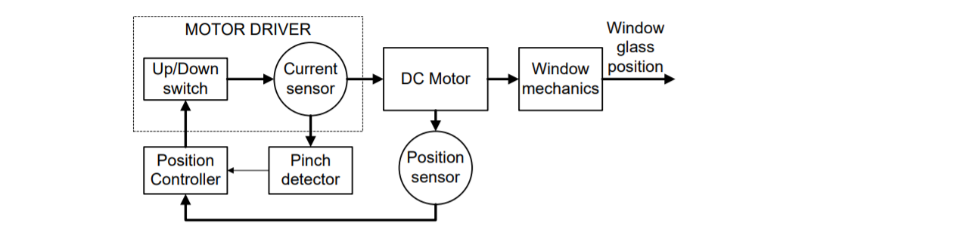

- Armature current:
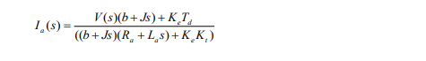
The DC motor current is the armature current Ia, and the pinch condition is obtained by processing this armature current. From the linear power window model in Figure 3, the total armature current Ia of the DC motor for the anti-pinch system is obtained as follows:

The block diagram for power window model is :



- Properties of the system
When the pinched object is detected by the system, the current rises until its value reaches to the threshold value. After the current hits the threshold level, the system defines this as pinch detection, and the motor starts moving in reverse to make the window glass go back down. When the pinch detection is made, the force sensor which attached on the experimental system is working to measure the squeezing force.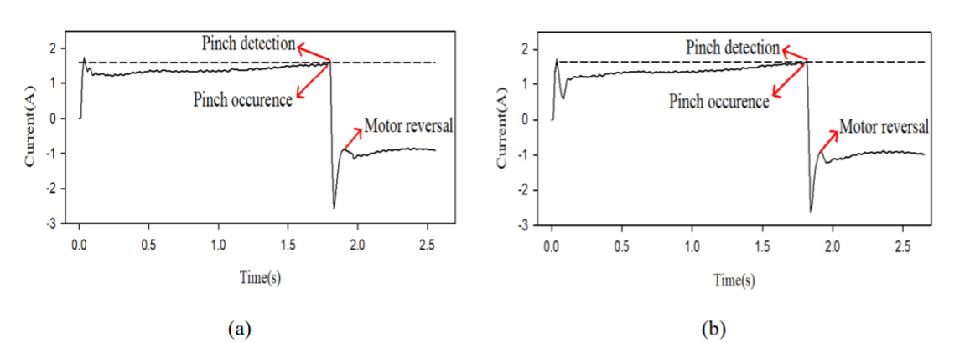
- Threshold Current:
A reasonable automatic threshold level to detect the pinch condition is 97% of the maximum current of the transient time.




IMPLEMENTATION:

Driver side window implementation:

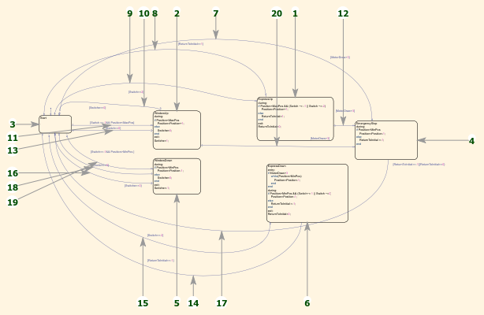

Passenger side window implementation:

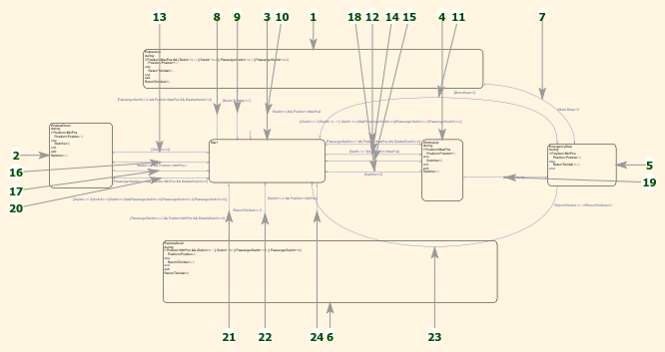

TEST PLANS

- High Level

Test ID | Description | Exp IN | Exp OUT | Actual Out | Type Of Test | TimeStamp
H_01 | Does Window go up on pulling up the rocker switch | 1 | Increase in window position from 1-5 | Position Increased | Requirement based | 0-5 sec
H_02 | Does Window go down on pushing down the rocker switch | -1 | Decrease in window position from 5-1 | Position Decreased | Requirement based | 0-5 sec
H_02 | The window should come to halt at any stage of operation by releasing the toggle switch | 1 | Increase in window position from 1-3 | Halted at 3 | Requirement based | 0-3sec
H_04 | The window should roll back on detection of pinch | Motor draw=4 | Window roll back | Window rolled back | Requirement based | 0-4sec

Low Level

Test ID | Description | Exp IN | Exp OUT | Actual Out | Type Of Test
L_01 | Driver wants to pull up and passenger wants to pull down the same window | Driver=1  Passenger=-1 | Increase in window position from 1-5 | Position Increased | Boundary Condition
L_02 | Driver wants to pull down and passenger wants to pull up the same window | Driver=-1  Passenger=1

IMPLEMENTATION:

